Robotic Systems

CW2: Group Reflective Report

# Group: “Juantxotl”

Carolina Avila

Yusseff Dominguez

Rodrigo Moreno

Esteban Ochoa

7th May 2019

# Research topic:

Our research goal is to optimize the robot’s behaviour to maximize grid coverage while having an acceptable mapping accuracy. In order to achieve this goal we have focused our work in the following two aspects:

1. Development of an exploration algorithm that plans and controls the trajectory followed by the robot.
2. Improvement of the robot’s pose estimation by using sensor fusion.

# System architecture and optimized subsystems:

A diagram of your systems architecture in relation to the task scenario.

With our research goal in mind, we have developed and optimized the following sub-systems:

1. **Path planning via an exploration algorithm** with the following features:
   1. Baseline trajectory is a zig-zag path from side to side of the grid.
   2. Online reading of the EEPROM map as it is generated to keep track of visited (the robot was physically in that cell) and explored cells (not visited but mapped using sensors information).
   3. The outcome of the algorithm is the next cell that the robot should go to. The priority is the closest non-visited cell. Cells mapped as obstacles are excluded from the selection.
   4. The performance of this exploration algorithm relies on the accuracy of the mapping function, therefore we have considered necessary to improve the pose estimation of the robot in addition to the development of this algorithm.
2. **Sensor fusion:**
   1. This has been implemented to improve the heading estimation and subsequently, the mapping accuracy.
   2. A Kalman filter has been implemented that merges the information coming from the encoders (angular velocity) and the gyroscope signal previously filtered.
   3. The magnetometer signal could be optionally added as part of the Kalman filter but we did not include the fusion of this sensor in our tested solutions. We have observed that the environmental conditions at the testing facilities affect the magnetometer readings significantly, therefore the information from this sensor is not considered sufficiently reliable.
   4. The heading estimation resulting from the sensor fusion is used to calculate the position (x,y) and update the pose of the robot.

**Obstacle avoidance** has been implemented at 2 different levels:

* Top level: Cells with obstacles are mapped during exploration using the information received by the distance sensors. This information is taken into account by the exploration algorithm in the selection of the next goal position, which avoids the robot going to those cells.
* Low level: A reactive obstacle avoidance behaviour has been added using an obstacle-avoidance function which uses a “potential field” algorithm. When the robot is too close to an obstacle according to the sensor readings, a resultant repulsive force is generated that changes the motion direction of the robot. This force results from the balance between the attractive force generated by the goal (directly proportional to the distance) and the repulsive forces generated by the obstacle (inversely proportional to the distance).

Explain problems observed and justification for activating and de-activating of this function in the tests. ○ How the findings influenced the development of your overall solution.

**Mapping function**:

We implemented the following features in the mapping function ……

We also modified the function writing on the EEPROM memory so that the map printed on the serial monitor has X coordinates on the horizontal and Y coordinates along the vertical.

# Experimental validation:

### Goal of the experiment:

Quantify the effect of different subsystem improvements on the coverage and mapping accuracy. Four different experiments have been carried out on the proposed map including obstacles. All the tests included the exploration algorithm with the difference being the implementation or not of the sensor fusion and low-level obstacle avoidance behaviour (Table 1):

|  |  |  |  |
| --- | --- | --- | --- |
| **Test #** | **Exploration Algorithm** | **Sensor Fusion** | **Low-level Obstacle avoidance** |
| 1 | Y | N | N |
| 2 | Y | N | Y |
| 3 | Y | Y | N |
| 4 | Y | Y | Y |

Table 1. List of tests carried out for experimental validation according to active subsystems/behaviours.

### Metrics:

For every experiment, coverage and mapping accuracy were evaluated using the following metrics:

**Coverage**: This is measured by two percentage values: % of visited and % of explored cells. This information will be extracted from two sources: the printed map and video-tracking of the robot’s path throughout the experiment. We have programmed a computer vision tracking algorithm that tracks and marks the robot’s trajectory over the map grid. This algorithm gives the number of visited and explored cells and is used as the ground truth method for verification of the robot’s printed map.

**Mapping accuracy**: This is proportional to the similarity between the map printed by the robot and the ground truth map, which is a matrix representing the information of the true map grid. The ground truth map is generated from …. (map file provided or video ground-truth tool). Comparing both maps we have quantified the percentage of cells identified correctly from the total of explored cells. We have also distinguished between ‘feature’ cells and ‘free’ cells.

### Materials and methods:

**Materials:**

- Obstacles were included in the map for all experiments.

- Romi control program: specific code version for each experiment according to Table 1.

- Sensors used (in addition to encoders):

- 3x Line Sensors

- 4x Proximity IR sensors.

- IMU: only gyroscope.

Note: RF sensor not considered necessary for the purpose of this research. Although mounted and included as an option in the code, magnetometer use was discarded due to high variance observed on the readings.

- Video recording of every experiment (tripod and mobile phone).

**Methods:**

Only one trial was performed and recorded for each type of experiment. Total duration of every test was 180 sec.

For every experiment, the recorded video was processed by the CV program to obtain a track of the full path followed by the robot. The outcomes of this video-tracking program are an image of the map with the grid and full path superimposed, the number of visited cells and the number of explored cells. This information was used as the ground truth for evaluation of the map coverage.

The maps printed by the robot were saved as txt files and later processed in Excel for results extraction. For each trial, the printed map was processed and compared to the ground truth obtained by the CV program in order to verify the trajectory and the cells visited by the robot. In addition, the printed map was compared to the ground truth map matrix (see below) in order to quantify the mapping accuracy.

**Generation of ground truth map matrix:**

* The image file provided with the map of the experiment was processed in Matlab to generate another image of the map with the grid on top (Figure 1). The grid has the same size defined in the robot’s mapping function (25 x 25 = 625 cells).
* From the above grid image, a ground truth map file was manually generated in Excel. This file has the same format as the map printed from EEPROM memory by the robot, using specific characters to identify content of different cells (Figure 2).

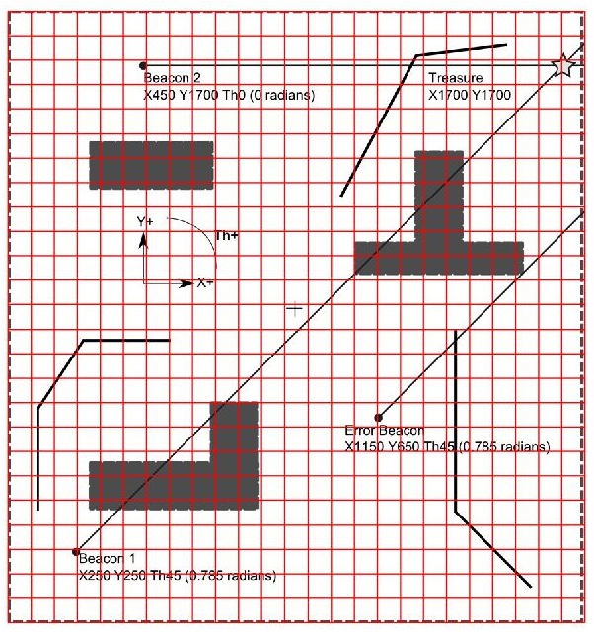

Figure 1. Processed image of the ground truth map with the grid.



Figure 2. Ground truth file created in excel from grid image of the map.

### Results:

Results for each experiment are summarized in Table 2. Results from the baseline experiment performed with a random motion behaviour previous to the development of different improvements have also been included for comparison.

 

Figure 3. Left: Ground truth matrix. Right: Map created by the robot in one of the experiments.

|  |  |  |  |  |  |
| --- | --- | --- | --- | --- | --- |
| **Metrics** | **Test 1** | **Test 2** | **Test 3** | **Test 4** | **Baseline**  **(20 sec.)** |
| **COVERAGE** |  | | | | |
| Absolute number of visited cells |  |  |  |  |  |
| % Visited cells |  |  |  |  |  |
| Absolute number of explored cells |  |  |  |  | **41.6** |
| % Explored cells |  |  |  |  | **6.66 %** |
| **MAPPING ACCURACY** |  | | | | |
| Absolute number of cells mapped as feature (Obstacle or Line) |  |  |  |  | **18.4** |
| Absolute number of ‘feature’ cells correctly identified |  |  |  |  | **7** |
| % of ‘feature’ cells correctly identified |  |  |  |  | **38.04%** |
| % Features detected during experiment |  |  |  |  | **6.25%** |
| Absolute number of cells mapped as free |  |  |  |  | **23** |
| Absolute number of free cells correctly identified |  |  |  |  | **20.2** |
| % of free cells correctly identified |  |  |  |  | **88.71%** |
| % Explored cells correctly mapped |  |  |  |  | **67.67%** |

Table 2. Summary of results. Metrics quantifying coverage and mapping accuracy.

**Results analysis and comparison between tests**

**Baseline behaviour**: For an experiment duration of 20 seconds, average percentage of explored cells (with regard to the total number of cells in the map) was 6.66% and feature-mapping was just 6.25% of the total number of obstacle/line feature cells. From the total of explored cells, 67.67% were correctly mapped either as ‘feature’ or ‘free’. Only 38% of the cells marked as features were correctly mapped.

**Further observations:**

* Did the robot hit any obstacle??.
* Did the robot went out of the map boundaries??

# Discussion:

Critical analysis of our methods, metrics, ground truth, etc.

Problems or difficulties found

Evaluation of level of improvement and contribution of each subsystem to that improvement

Propose future improvements

# Conclusions